**Test Plan**

**Project “**CALIFORNIA MARKETING**” (**<https://qasvus.wixsite.com/ca-marketing>**)**

**Table of Contents:**

1. Introduction
2. Scope
3. Quality Objectives
4. Test Approach
5. Entry And Exit Criteria
6. Suspension Criteria And Resumption Requirements
7. Test Strategy
8. Resource And Environment Needs
9. Test plan for each Testing type performed in this project

1. INTRODUCTION

Customers want a perfect website, which passes the full cycle of manual testing. Given the specificity of the site it is important to have the same quality of the site as per requirements.

This Test Plan has been created to facilitate communication within the team members. This document describes approaches and methodologies that will apply to the unit, functional, performance and security testing of the <https://qasvus.wixsite.com/ca-marketing>. It includes the objectives, test responsibilities, entry and exit criteria, scope and approach. This document has clearly identified what the test deliverables will be, and what is deemed in and out of scope.

2. SCOPE

The document mainly targets the GUI testing, positive and negative testing, and validating data in report output as per Requirements Specifications provided by Client.

3. QUALITY OBJECTIVES

A primary objective of testing is to: assure that the system meets the full requirements, including quality requirements (functional and non-functional requirements) and fit metrics for each quality requirement and satisfies the use case scenarios and maintain the quality of the product.

The secondary objectives of testing will be to identify and expose all issues and associated risks, communicate all known issues to the project team, and ensure that all issues are addressed in an appropriate matter before release.

4. TEST APPROACH

Analytical test approach was used, in accordance with requirements-based strategy, where an analysis of the requirements’ specification form is the basis for planning,estimating and designing tests. Test cases will be created during exploratory testing. All test types are determined in Test Strategy.

The project is using an agile approach, with weekly iterations. At the end of each week the requirements identified for that iteration will be delivered to the team and will be tested.

5. ENTRY AND EXIT CRITERIA

Entry Criteria

* Proper test data should be available.
* All the necessary documentation, design, and requirements information should be available that will allow testers to operate the system and judge the correct behavior.
* All the standard software tools including the testing tools must have been successfully installed and functioning properly.
* All test hardware platforms must have been successfully installed, configured, and functioning properly.

Exit Criteria

* No high priority or severe bugs are left outstanding.
* A certain level of requirements coverage has been achieved.
* All high-risk areas have been fully tested, with only minor res idual risks left outstanding.
* Cost – when the budget has been spent.
* The schedule has been achieved.

6. SUSPENSION CRITERIA AND RESUMPTION REQUIREMENTS

Suspension criteria

* Software/Hardware problems.
* Significant change in requirements suggested by client.
* The build contains many serious defects which seriously or limit testing progress.
* Assigned resources are not available when needed by test team.

Resumption criteria

* Resumption will only occur when the problem that caused the suspension has been resolved.

7. TEST STRATEGY

QA role in test process:

* Understanding Requirements.
* Requirement specifications will be sent by client.

Preparing Test Cases:

* QA will be preparing test cases based on the exploratory testing. This will cover all scenarios for requirements.

Reviewing test cases:

* Review for test cases will be conducted by QA Lead.
* Any comments or suggestions on test cases and test coverage will be provided by reviewer
* Suggestions or improvements will be updated by the preparer and sent to QA Lead for approval.
* Updates and improvements will be reviewed and approved by the reviewer.

Creating Test Data:

* Test data will be created by respective QA based on scenarios and Test cases.

Executing Test Cases:

* Test cases will be executed by respective QA based on designed scenarios, test cases and Test data.
* Test result (Actual Result, Pass/Fail) will be updated in test case document Defect Logging and Reporting: QA will be logging the defect/bugs in Excel spreadsheet and JIRA, found during execution of test cases.

Retesting and Regression Testing:

* Retesting for fixed bugs will be done by respective QA once issue is resolved by respective developer and bug/defect status will be updated accordingly. In certain cases, regression testing will be done if required.

Deployment/Delivery:

* Once all bugs/defect reported after complete testing is fixed and no other bugs are found,report will be deployed to the client, along with sample output by email to respective lead and Report group

Testing types:

**Manual Testing:**

* Exploratory testing – includes a type of software testing where Test cases are not created in advance but QA checks system “hands-on”. QA may note down ideas about what to test before test execution.
* Positive testing – includes the type of testing that can be performed on the system by providing the valid data as input. It checks whether an application behaves as expected with positive inputs.
* Negative testing – also known as failure testing or error path testing, is a method of testing an application or system that ensures that the plot of the application is according to the requirements and can handle the unwanted input and user behavior. Invalid data is inserted to compare the output against the given input.
* Black box testing – also called behavioral testing or Partition testing. This kind of testing focuses on the functional requirements of the software. It enables one to derive sets of input conditions that will fully exercise all functional requirements for a program.
* GUI Testing – GUI testing will include testing of the UI part of report. It covers users Report format, look and feel, error messages, spelling mistakes, GUI guideline violations.
* User acceptance testing:

The purpose behind user acceptance testing is to confirm that system is developed according to the specified user requirements and is ready for operational use. Acceptance testing is carried out at two levels - Alpha and Beta Testing. User acceptance testing (UAT) will be done at the Client.

* Boundary Testing - the process of testing between extreme ends or boundaries between partitions of the input values.
* ADHOC testing – includes an informal testing type with an aim to break the system.

**Automation Testing:**

Functional Automation testing - testing of website’s interface and functionality using Selenium Webdriver. Functional testing is carried out in order to find out unexpected behavior of the report. The purpose of functional testing is to provide correctness, reliability, testability and accuracy of the report output/data.

API testing - testing of correct form of API requests, JSON body using Postman API.

Performance Automation testing - testing of website’s performance with Lighthouse, GTMetrix, SpeedLab. Performance Testing:

* Check the optimal time the page is loaded
* Check the operation of the system under load

Automation Security testing - a type of software testing that intends to uncover vulnerabilities of the system and determine that its data and resources are protected from possible intruders.

**Bug Severity and Priority Definition. Bug Life Cycle.**

Bug Severity and Priority fields are important for categorizing bugs and prioritizing if and when the bugs will be fixed. QA Tester will assign a severity level to all bugs. The QA Test Lead will be responsible to see that a correct severity level is assigned to each bug.

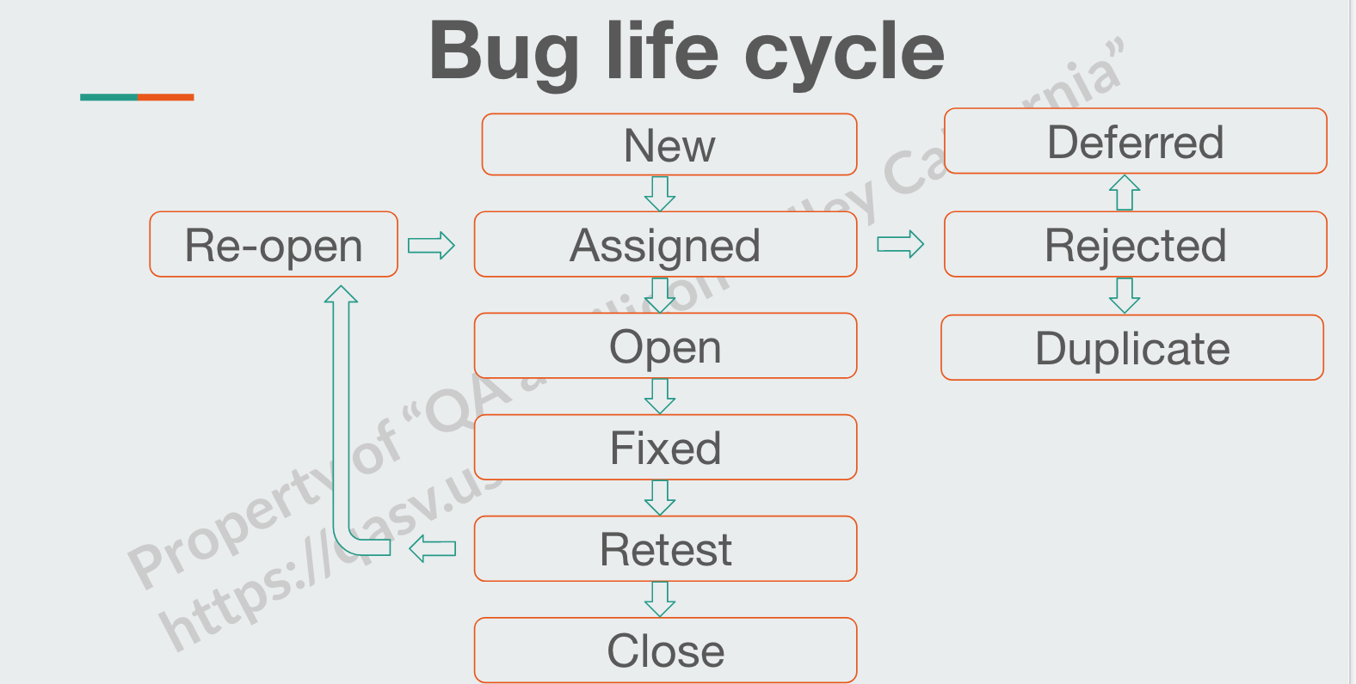

1. RESOURCES AND ENVIRONMENT NEEDS

**Testing Tools for Manual Testing:**

| **Process** | **Tool** |
| --- | --- |
| Test case creation | Microsoft Word, Microsoft Excel, JIRA |
| Test case tracking | JIRA, Confluence |
| Test case execution | Manual, Automation (Selenium Webdriver, Postman API) |
| Test case management | Microsoft Excel, JIRA, Confluence |
| Test reporting | JIRA |
| Check list creating | Microsoft Excel, JIRA |

**Testing Tools for Automation Testing:**

| **Process** | **Tool** |
| --- | --- |
| Functional Automation Testing | Selenium Webdriver |
| API Testing | Postman API |
| Performance Automation testing | Manual, Automation (Selenium Webdriver, Postman API) |
| Test case management | Lighthouse, GTMetrix, SpeedLab |
| Automation Security testing | Selenium Webdriver |

Test Environment x Support level 1 (browsers):

* Windows 10 : Google Chrome Version 92
* Windows 10 : Mozilla Firefox Version 93.0
* Windows 10 : Edge

1. TEST PLAN FOR EACH TESTING TYPE IN THIS PROJECT
2. Manual Testing:

Exploratory Positive: Within 5 minutes we are going to verify the main functionality of the given website, such as:

* Verify login with valid username and password.
* Verify the link product 2 (Lipstick) in the main window is functional.
* Verify the completion of the “Subscribe Form Email address” is correct.
* Verify that the user can pick color and quantity "I'm a product 12".
* Verify that the user can create a board on https://www.pinterest.com/pin/create/button from tab "Shop" "I'm a Product 2".

Exploratory Negative: (approximate time - 3 minutes)

* Verify that invalid email id and valid password is entered.
* Verify that invalid email id and invalid password is entered.
* Verify the completion of the “Subscribe Form Email address” using the same positive integer is invalid.
* Verify that the user can not enter 0 in the quantity button.

Boundary Testing: (approximate time - 3 minutes)

* Verify that the user can not enter 0 in the quantity button.
* Verify that the user can enter 1 in the quantity button .
* Verify that the user can enter 2 in the quantity button.
* Verify that the user can enter 99998 in the quantity button.
* Verify that the user can enter 99999 in the quantity button.
* Verify that the user can not enter 100000 in the quantity button.

Cross-Browser Testing: (approximate time - 6 minutes)

* Check that the Product 12 picture is functional .
* Check Colour and quantity change are functional.
* Check ‘Add to cart', 'view cart' buttons are functional.
* Check that the Checkout button is functional.
* Check that the ‘Services' button is functional.
* Check that the ‘Awesome service' window is functional.
* Check that the ‘More' and 'plans & prices' button are functional.

1. Automation Testing. Within 2 hours we are going to write the script for the given website, to verify the main functionality, such as:

* Google opens the website for **https://qasvus.wordpress.com/.**
* Maximize window.
* Validate and print the page title.
* Close all pop-up windows.
* Find the 1st image on the page.
* Scroll down the page, find the ‘Send Us a Message’ section.
* Fill in all 3 fields: name, e-mail, message
* Submit the form and go back.

1. API Testing. Within 3 hours we are going to write the script for the given website, to verify the main functionality, such as:

* Create a new address at the <https://qasvus.wixsite.com/ca-marketing/account/my-addresses>.
* Get information about all the addresses on the page.
* Get the specific address which was created.
* Modify the specific address.
* Get the modified address and check it.
* Delete the modified address.
* Delete the modified address 2nd time.
* Get the deleted address, check that it was deleted.

1. Performance Automation Testing with Lighthouse and GTMetrix:

* We are getting a general performance outlook of the [https://qasvus.wixsite.com/ca-marketing](https://qasvus.wixsite.com/ca-marketing/account/my-addresses) website using Lighthouse Chrome extension and GTMetrix tool. Approximate time - 5 minutes.

1. Automation Security Testing: (approximate time - 3 minutes)

* We are testing security of the [https://qasvus.wixsite.com/ca-marketing](https://qasvus.wixsite.com/ca-marketing/account/my-addresses) using the website scanner tool at the Snyk.io website.